PROGRESS REPORT TEMPLATE FOR
SYSTEM CAPACITY GRANT

OVERVIEW
Country: | Click to enter text.
Grant ID (if applicable): | Click to enter text.
Grant agent: | Click to enter text.
Grant effectiveness/start date: | Click or tap to enter a date.
Grant amount (in the grant approved currency): | Click to enter amount.
Time frame examined in this report (insert the timeframe as follows: from: month, day, year, to: month, day, year ): | Click to enter text.
Date of report submission: | Click or tap to enter a date.
Area(s) and activity group(s) covered by grant (check all that apply):
☐ Financing window 1: Strengthen gender-responsive planning and policy development for system-wide impact
☐ A System diagnostics, compact development and education sector analyses
☐ B. Gender-responsive sector planning, including operational planning and budgeting
☐ C. Supporting policies and plans to identify and address multiple forms of exclusion (planning for children with disabilities, system resilience and inclusion of displaced children)
☐ D. Strengthening evidence-based diagnosis of critical implementation bottlenecks and identifying potentially scalable, transformative solutions
☐ Financing window 2: Mobilize coordinated action and financing to enable transformative change
☐ E. Strengthening sector coordination, including local education groups, joint sector reviews and monitoring the effectiveness of the country-level partnership
☐ F. Establishing and operating pooled funding mechanisms
☐ G. Strengthening budget processes and ministry of finance engagement; identifying opportunities to improve the equity and efficiency of education expenditure, including processes toward gender equality
☐ H. Cross-sectoral convening
☐ Financing window 3: Strengthen capacity, adapt, and learn, to implement and drive results at scale
☐ I. Strengthening data systems, including on improving the availability and use of sex-disaggregated data, and data on children with disabilities
☐ J. Training and support for government staff and central and decentralized levels, including on the uptake and use of data and evidence
☐ K. Support for implementation capacity, including sector plan implementation monitoring, gender responsiveness of the sector and evaluation of sector plans and policies/programs in priority areas; assess monitoring, evaluation and learning capacity, including use of evidence in policy process
PURPOSE AND INSTRUCTIONS
Purpose
This system capacity grant annual progress report is learning oriented and seeks to:
- Assess and report on the performance progress and achievements of the grant in specific capacity areas for this reporting period, to inform improvements in the implementation of the grant so as to ensure that its intended aims are fulfilled.
- Share lessons to improve the grant activities and priorities.
- Ensure accountability and transparency of the grant and its commitments.
Instructions
This template is to be completed by the grant agent, after consultation with the government and local education group. As per the Guidelines for System Capacity Grants, the grant agent completes a system capacity grant implementation progress report on a yearly basis. The first annual progress report must cover the first 12 months of implementation and must be submitted no later than three months after the first anniversary of the official grant effectiveness/start date. The second annual progress report must be submitted no later than three months after the second anniversary of the official grant effectiveness/start date. And so forth.
The full report package consists of the following deliverables:
- Completed template (present form, including relevant annexes)
- Tangible outputs and knowledge products generated with system capacity grant support this reporting period
Text should be concise and clear. You may add annexes if you wish to display only key text in the report. Overlapping contents may be referenced cross-sectionally to avoid repetitions. It is encouraged to think of the questions as an interdependent whole to build the project’s story line. Some questions are self-reflective in nature and will necessitate using judgment inferred from triangulated quantitative/qualitative information and logical explanations.
Include a gender and equity lens in the narratives, as much as feasible. Evidence and findings should be placed back into the national/subnational context of the country at the time of the review, for better unpacking the information.
The grant agent should submit the report through the GPE reporting portal. If you have not received access to the portal yet, please contact the grant operations officer for your country. In the meantime, the report should be submitted via email to gpe_grant_submission@globalpartnership.org, copying the coordinating agency and the GPE Secretariat country team lead. Following submission, the grant agent may be contacted by the GPE Secretariat for additional information or clarification. The report will be publicly disclosed after it is submitted by the grant agent and reviewed by the GPE Secretariat. Please reach out to your GPE Secretariat primary contact in case of questions.
LIST OF ACRONYMS
Please insert the list of acronyms used in this report, if any.
Click here to add acronyms.

1. IMPLEMENTATION PROGRESS
1.1 Overall grant progress this reporting period
Indicate the overall level of progress in implementing the grant activities this reporting period across the three capacity areas, taking into consideration the progress of the individual system capacity grant activities/capacity deliverables, level of financial absorption and management performance (that is, project and financial management, procurement, monitoring/evaluation, financial reporting requirements, any other compliance requirements). | Overall progress this reporting period: Select a rating.
To explain the progress rating above, please describe:
- Major accomplishments this reporting period.
- Which implementation challenges or delays the project experienced this reporting period; the reasons behind these issues; how (well) these have been mitigated thus far; and what remains to be done by whom and by when to address the challenges.
- Factors that led to any upgrade/downgrade in the progress rating above, compared with the previous reporting period (if any).
- Whether any progress was made in mitigating previous reporting periods’ challenges or delays (if any).
Click to enter text.
For projects with an overall rating of Moderately Unsatisfactory or below this reporting period:
Describe priority actions for the following reporting period to overcome constraints, build on achievements and partnerships, and use the lessons learned during the reporting period.
Click to enter text.
1.2 Grant progress by window
Provide in annex 2 information on the level of implementation progress for each grant capacity area window this reporting period:
- Progress ratings by window
- Brief narrative on key activities undertaken and deliverables completed, by component/objective
Click here to enter text.
1.3 Lessons, innovative/promising practices
Indicate any emerging successful practices, innovative interventions in relation to the implementation of the grant during this reporting period.
Click here to enter text.
1.4 Impact stories
This reporting period, have you identified any stories of impact of the project on beneficiaries that you would like to share with the GPE Secretariat Communications Team? If so, provide below or as an attachment. These stories will be featured on our communications materials and platforms, with attribution to the provider.
Click here to enter text.
1.5 Tangible outputs and knowledge products
Attach the tangible outputs and knowledge products (for example, evaluations, pilots, studies, etc.) generated through the support of the grant this reporting period. Also, attach any photos, videos, advocacy posters, and so on. as relevant that can be showcased in GPE stories or blogs.

2. FINANCIAL REPORTING AND GRANT MANAGEMENT
2.1 Financial reporting on GPE grant
Cumulative financial absorption rate: Provide a financial absorption rate based on cumulative expenditure expressed as a percentage of the approved budget to date and a rating. |  | Approved budget to date: Click here to enter number.
 |  | Cumulative expenditure: Click here to enter number.
 |  | Cumulative financial absorption rate: Click here to enter number.
 |  | Level of financial absorption: Select a rating.
If the financial absorption is not rated as On Track, please provide an explanation that identifies the main activities that have been delayed and their corresponding unspent amounts, as well as reasons for the delay and steps taken to ensure that expenditure absorption gets on track in the next reporting period.
Click here to enter text.
Budget variance analysis for the current reporting period:
(i) Total approved budget for the current reporting period | (ii) Total expenditure for the current reporting period | (iii) Explanation for underspending or overspending in excess of 10 percent
Click here to enter number. | Click here to enter number. | Click here to enter text.

2.2 Management performance
Provide a rating to indicate the performance of the grant during implementation in terms of its management this reporting period. This includes financial, procurement, social/environmental safeguards, monitoring & evaluation, implementation arrangements, and other fiduciary management or compliance duties. | Level of management performance: Select a rating.
Explain how these management arrangements/duties have affected, positively or negatively, the implementation of the grant and its progress toward achieving results/outcomes. Note any management-related issues or shortcomings during the period under review and how these have been/are being remediated. Why or why not?
Click here to enter text.

2.3 Revisions to the grant
This reporting period:  This period, have there been any revisions to the grant other than those submitted to the GPE Board or Secretariat for their approval? | In the next twelve months:  How likely is it that the government and the grant agent will submit a request for revision to the GPE Board or Secretariat in the next twelve months for their approval?
Yes/No. | Select from the list.
If yes, please describe them. | If Moderately Likely or above, please explain.
Click here to enter text. | Click here to enter text.

Annex 1: Decision Trees for Overall Progress Rating and Window-Level Progress Ratings 1. Overall progress rating
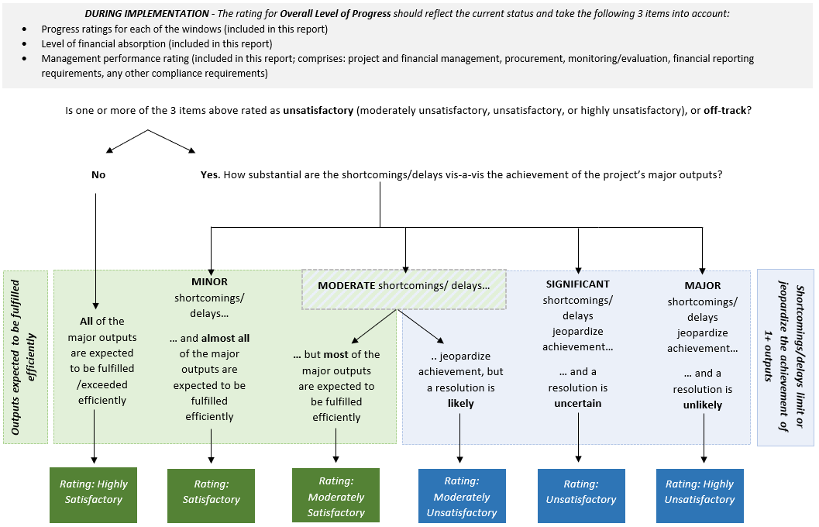

2. Window-level progress ratings
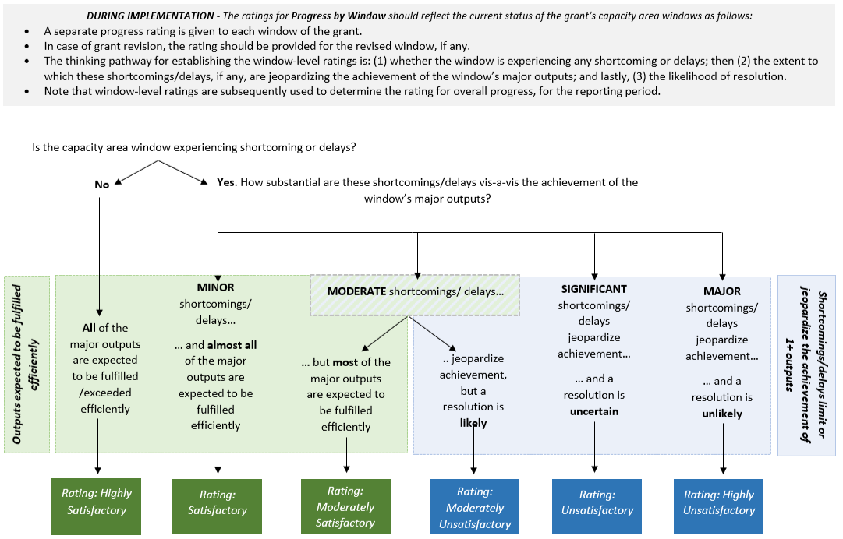

Annex 2: Grant Implementation Progress, by Window
Implementation of the grant’s capacity area window this reporting period
Indicate the level of progress for each grant window this reporting period:
- First, select a rating to assess the level of progress, for each of the three windows of capacity areas, in implementing the key activities scheduled and completing planned capacity deliverables during this reporting period. If the grant is not undertaking activities for certain windows, please select Not Applicable in the dropdown menu for that window.
- Then, provide a brief narrative for each window, indicating:
- Which key activities took place and their relative level of success (and the reasons for any lack thereof);
- Which outputs/deliverables were completed; and
- Whether the grant is (on its way to) fulfilling or not its assigned systemic capacity strengthening purposes in the capacity area.
Capacity area window 1: Strengthen gender-responsive planning and policy development for system-wide impact
Select a rating on the level of progress this reporting period. | Click here to enter text for the brief narrative.
Capacity area window 2: Mobilize coordinated action and financing to enable transformative change
Select a rating on the level of progress this reporting period. | Click here to enter text for the brief narrative.
Capacity area window 3: Strengthen capacity, adapt, and learn, to implement and drive results at scale
Select a rating on the level of progress this reporting period. | Click here to enter text for the brief narrative.

Notes

“Effectiveness” (start) date is considered as the date when the grant implementation ha effectively started, marked by the occurrence of an event defined in the grant application.
See the Guidelines for System Capacity Grants.
15 months at the latest after the official start date.
See in Annex 1 a decision tree to help determine an overall rating for implementation progress. The scale is as follows: Highly Unsatisfactory – The project has major shortcomings or delays that limit or jeopardize the achievement of one or more outputs and a resolution is unlikely. Unsatisfactory – The project has significant shortcomings or delays that limit or jeopardize the achievement of one or more outputs and a resolution is uncertain. Moderately Unsatisfactory – The project has moderate shortcomings or delays that limit or jeopardize the achievement of one or more outputs, but a resolution is likely. Moderately Satisfactory – The project is expected to achieve most of its major outputs efficiently with moderate shortcomings or delays. Satisfactory – The project is expected to achieve almost all of its major outputs efficiently with only minor shortcomings or delays. Highly Satisfactory – The project is expected to achieve or exceed all of the major outputs efficiently without significant shortcomings or delays.
Factors may include but are not limited to the following: Grant management (management arrangements, roles and responsibilities), grant supervision (provided supervision during the implementation, including timely and proactive identification of issues and actions taken to address them), factors related to capacity (including institutional and organizational capacities, human resources–related capacities and other issues that impact capacity), financial management/fiduciary issues (including adequate procurement, financing, budgeting and financial management mechanisms in place following the grant agent’s policies and procedures), Monitoring and evaluation (quality of M&E arrangements, including M&E design, implementation and utilization to inform project/grant management and decision making; issues related to data availability and so on), coordination, partnership and participatory processes (principal project partners, their roles and engagement; information on frequency and reasons for consultations with the local education group during the grant implementation), external factors, factors beyond the grant agent’s control and unforeseen circumstances (macroeconomic changes, conflict and instability, natural disasters, changes in government commitment and leadership, issues related to governance and politics, unforeseen technical and logistical difficulties, changes in project scope and so on), any other challenges and constraints, and factors contributing to problems or success in the grant implementation.
See in Annex 1 a decision tree to help determine component/objective-level implementation progress ratings.
Approved budget refers to the version of the budget that has been approved by the GPE Board (or relevant committee/Secretariat in their delegated authorities) or the revised version of the budget that has been duly approved in accordance with the provisions for revisions specified in the education sector program implementation grant policy.
Expenditure refers to the amount paid out by implementing partners or grant agents to third parties for services performed or goods delivered. It should not include commitments, which refer to the amount that implementing partners or grant agents have an obligation to pay based on signed contracts and following satisfactory contract performance.
Cumulative financial absorption rate can be calculated by using the following formula: Cumulative financial absorption rate (%) = (Cumulative expenditure)/(Approved budget to date) * 100
Off Track – Cumulative absorption rate is less than 75 percent. Slightly Behind – Cumulative absorption rate is greater than or equal to 75 percent but less than 90 percent. On Track – Cumulative absorption rate is greater than or equal to 90 percent.
Highly Unsatisfactory – Major shortcomings in grant performance management jeopardize the capacity to provide timely and reliable provision of information required to manage and monitor the implementation of the project and a resolution is unlikely. Unsatisfactory – Significant shortcomings in grant performance management jeopardize the capacity to provide timely and reliable provision of information required to manage and monitor the implementation of the project and a resolution is uncertain. Moderately Unsatisfactory – Moderate shortcomings in grant performance management jeopardize the capacity to provide timely and reliable provision of information to manage and monitor the implementation of the project, but a resolution is likely. Moderately Satisfactory – Moderate shortcomings in grant performance management exist but do not prevent the timely and reliable provision of information required to manage and monitor the implementation of the project. Satisfactory – Minor shortcomings in grant performance management exist but do not prevent the timely and reliable provision of information required to manage and monitor the implementation of the project. Highly Satisfactory – The grant performance management system efficiently and reliably provides timely information required to manage and monitor the implementation of the project. Appropriate internal controls are in place and function effectively.
Revisions to the project are regulated by the Policy on Education Sector Program Implementation Grants. The policy describes the approval process for different types of revisions. Mentioning a revision in the implementation report doesn’t exonerate from following due process.
Highly Unlikely – A request for revision is extremely unlikely to be submitted to the GPE Board or Secretariat for their approval in the next 12 months. Unlikely – A request for revision is unlikely to be submitted to the GPE Board or Secretariat for their approval in the next 12 months. Moderately Unlikely – A request for revision is somewhat unlikely to be submitted to the GPE Board or Secretariat for their approval in the next 12 months. Moderately Likely – A request for revision is somewhat likely to be submitted to the GPE Board or Secretariat for their approval in the next 12 months. Likely – A request for revision is likely to be submitted to the GPE Board or Secretariat for their approval in the next 12 months. Extremely Likely – A request for revision is extremely likely to be submitted to the GPE Board or Secretariat for their approval in the next 12 months.
See in annex 1 a decision tree to help determine implementation progress ratings at the window level. The scale is as follows: Highly Unsatisfactory – The window has major shortcomings or delays that limit or jeopardize the achievement of one or more outputs and a resolution is unlikely. Unsatisfactory – The window has significant shortcomings or delays that limit or jeopardize the achievement of one or more outputs and a resolution is uncertain. Moderately Unsatisfactory – The window has moderate shortcomings or delays that limit or jeopardize the achievement of one or more outputs, but a resolution is likely. Moderately Satisfactory – The window is expected to achieve most of its major outputs efficiently with moderate shortcomings. Satisfactory – The window is expected to achieve almost all of its major outputs efficiently with only minor shortcomings or delays. Highly Satisfactory – The window is expected to achieve or exceed all of the major outputs efficiently without significant shortcomings or delays.

